
Master of Science – Data Science [2026-2028 Batch]
Department of Computer Application

Semester – I
Machine Learning for Data Science [Z5AMC 26100]
Mini Project Report
Air Quality Index (AQI) Prediction

Submitted By:
Name: LOGITH M
Reg. No.: PORV/ASOS/MSC/7/26/030
Date: 01-11-2026

Submitted To:
Faculty Name: Dr. Vivek Mishra

Department of Computer Application
Alliance University
Chandapura - Anekal Main Road, Anekal
Bengaluru – 562106

DEPARTMENT OF COMPUTER APPLICATION
ALLIANCE SCHOOL OF ADVANCED COMPUTING
ALLIANCE UNIVERSITY


CERTIFICATE

This is to certify that the Mini Project work entitled “AIR QUALITY INDEX (AQI) PREDICTION FOR BENGALURU USING EXPLAINABLE MACHINE LEARNING” is the bonafide work carried out by LOGITH M, submitted towards the internal mark requirements for the course Z5AMC 26100 – MACHINE LEARNING FOR DATA SCIENCE, Master of Science – Data Science, during the year November 2026.

Dr. Vivek Mishra,
Faculty, ASAC

ABSTRACT
Air pollution is one of the most serious environmental and public-health problems of fast-growing Indian cities, and Bengaluru is no exception. Heavy traffic, continuous construction, industrial clusters such as Peenya and unfavourable weather push the National Air Quality Index (AQI) into unhealthy ranges on many days. Monitoring stations report what the air quality was, but rarely explain which pollutant is responsible or warn that it is about to worsen. This project builds a predictive and explainable machine learning system for Bengaluru that estimates the AQI from pollutant and weather readings, identifies the main pollutants driving it and forecasts whether the AQI will rise in the next hour, to support citizens, schools, hospitals, traffic authorities and urban planners.
The pipeline was implemented in Python with pandas, NumPy, Matplotlib, Seaborn, scikit-learn, XGBoost and SHAP. A dataset of 427,440 observations from seven KSPCB/CPCB zones of Bengaluru (Hebbal, Peenya, Central Silk Board, Jayanagar 5th Block, BTM Layout, Bapuji Nagar and City Railway Station) was cleaned by median imputation and enriched with temporal features. Linear Regression, Random Forest, Gradient Boosting and XGBoost were trained on an 80:20 split using nine pollutant and weather predictors and compared by RMSE, MAE and R². Feature importance and SHAP beeswarm plots explained the best model, a class-balanced Logistic Regression classifier predicted next-hour AQI rise, and an interactive HTML5/JavaScript page was built for real-time use.
XGBoost performed best, with R² = 0.9841, RMSE = 6.24 and MAE = 4.18 on 85,488 unseen records, against R² = 0.8120 and RMSE = 21.43 for Linear Regression, showing that the relationship is strongly non-linear. PM₁₀ (56.86%) and PM_{2.5} (27.11%) together account for 83.97% of the model’s decisions, in line with the CPCB maximum sub-index rule; PM_{2.5} and PM₁₀ correlate with AQI at r = 0.88 and 0.84, and wind speed at r = −0.32. The next-hour classifier reached 72.8% accuracy, and the web page returns the AQI, its health category and the rise probability instantly.

TABLE OF CONTENTS
Abstract 3
1. Introduction 5
1.1 Background
1.2 Problem Statement
1.3 Aim and Objectives
1.4 Scope of the Project
2. Literature Review 7
3. Proposed Architecture 9
4. Methodology and Implementation 11
4.1 Dataset and Software Environment
4.2 Data Preprocessing and Feature Engineering
4.3 Exploratory Data Analysis and Correlation Analysis
4.4 Regression Models and Evaluation Metrics
4.5 Model Benchmarking Results
4.6 Feature Importance and SHAP Explainability
4.7 Next-Hour AQI Rise Classification
4.8 Interactive Web Application
4.9 Summary of Results and Discussion
5. Conclusion 21
6. References 22

1. INTRODUCTION

1.1 Background
Air pollution has grown into a chronic public-health problem in Indian metropolitan cities. Bengaluru, the technology capital of the country, has expanded very quickly over the last two decades, and this growth has come with heavy environmental costs: more than eleven million registered vehicles, long-running metro and road construction, dust re-suspended from roads, and emissions from industrial areas such as Peenya. Ambient air quality in India is communicated through the National Air Quality Index (AQI) defined by the Central Pollution Control Board (CPCB), a number from 0 to 500 grouped into the categories Good, Satisfactory, Moderate, Poor, Very Poor and Severe [11].
Predicting the AQI is not simple, because pollutants interact with each other and with temperature, humidity and wind in non-linear ways, and classical dispersion models often struggle with the irregular layout of a city. Supervised machine learning learns these patterns directly from measured data; recent studies show that ensemble tree models perform very well on air quality data [1], [8], [10] and that explainability methods are needed so that predictions can be trusted [5], [9]. This project applies that idea to Bengaluru.

1.2 Problem Statement
Air quality monitoring in Bengaluru is mostly descriptive: stations record pollutant concentrations and the values are published afterwards, so the public learns what the pollution level was rather than what it will be. Public dashboards show an AQI number but do not explain which pollutant is responsible, there is no simple signal telling asthma patients, schools or traffic authorities whether air quality will worsen in the next hour, and there is no accessible tool in which a person can enter sensor readings and receive a predicted AQI with a health advisory. The problem addressed here is therefore: how can machine learning predict Bengaluru’s AQI accurately, explain which pollutants drive it, and warn of a likely rise in the next hour, in a form that ordinary users can try for themselves?

1.3 Aim and Objectives
Aim: To design, train, evaluate and deploy an explainable machine learning pipeline for Bengaluru that predicts the Air Quality Index, identifies the dominant pollutants, forecasts whether the AQI will rise in the next hour, and offers the results through an interactive web interface.
The objectives set for this project were:
• Collect and prepare 427,440 observations from seven KSPCB/CPCB monitoring zones of Bengaluru, using median imputation for missing values and extracting temporal features (hour, day, month, day of week).
• Explore the data visually and statistically, using AQI distribution plots, 24-hour diurnal and monthly trends, and a Pearson correlation heatmap between pollutants, weather variables and AQI.
• Train and compare four regression models (Linear Regression, Random Forest, Gradient Boosting and XGBoost) on an 80:20 split using RMSE, MAE and R², and select the best model.
• Explain the best model with feature importance, a PM_{2.5}-versus-AQI trend analysis and SHAP plots, so that the question of which pollutant affects the AQI the most, and why, is answered with evidence.
• Build a class-balanced Logistic Regression classifier that predicts whether the AQI will be higher in the next record than in the current one, together with the probability of a rise.
• Deploy the results as an interactive HTML5/CSS3/JavaScript web page that takes sensor readings and returns the predicted AQI, its CPCB health category and the next-hour rise probability.

1.4 Scope of the Project
The scope of this project covers data analysis, regression modelling, model explanation, binary classification and a client-side web interface, using the 2024–2025 continuous ambient air quality monitoring records for Bengaluru from KSPCB and CPCB. The variables modelled are PM_{2.5}, PM₁₀, NO₂, SO₂, CO, O₃, temperature, relative humidity and wind speed, with AQI as the target. The project does not include building physical sensors, atmospheric chemical-transport simulation, or a production deployment with live data feeds.

2. LITERATURE REVIEW
Ten recent studies on machine learning for air quality prediction, explainability and the Indian AQI were reviewed to ground the design choices of this project. Each is summarised below in the reviewer’s own words, with the emphasis on what it contributes to predicting Bengaluru’s AQI, finding its drivers and warning of a rise.
Ameer and co-authors compare four advanced regression techniques for predicting air quality in smart cities, looking at both error and processing time as data size grows, including hyperparameter tuning on Apache Spark. The paper supports judging several regressors side by side under identical conditions, which is the approach used in this project’s benchmarking [1].
Zhai and Chen build a stacked ensemble for forecasting daily PM_{2.5} in Beijing, combining LASSO, AdaBoost, XGBoost and a genetic-algorithm-tuned neural network. The ensemble reached an R² of 0.90 and an RMSE of 23.69 µg/m³, and a feature-importance analysis showed which pollutants mattered most. The work supports using boosted trees together with feature-importance analysis, as done here [2].
Kumar and Goyal forecast the daily AQI of Delhi from the previous day’s AQI and meteorological variables using principal component regression, with the AQI computed through the sub-index and breakpoint method of the Indian standards. It is an important Indian precedent for predicting the AQI from weather and pollutant information and for the sub-index logic used in this project [3].
Nagendra, Venugopal and Jones assess air quality near traffic intersections in Bangalore using an air quality index. It is an early Bengaluru-specific study that treats busy junctions as places where the index needs close examination, which fits this project’s inclusion of traffic-heavy zones such as Central Silk Board, Hebbal and City Railway Station [4].
Lundberg and Lee introduce SHAP (SHapley Additive exPlanations), which assigns every feature a contribution to an individual prediction using Shapley values from cooperative game theory, with the properties of local accuracy and consistency. Because it works well with tree ensembles, it is used here to show whether high pollutant values push the predicted AQI up or down [5].
Chen and Guestrin present XGBoost, a scalable tree-boosting system built on a regularised objective, sparsity-aware split finding, column subsampling and shrinkage. Its speed and resistance to overfitting on tabular data explain its popularity in environmental regression, and it is the best-performing model in this project’s benchmark [6].
Al-Eidi and co-authors compare Random Forest, Linear Regression and Decision Tree regression for air quality prediction in smart cities, with a workflow covering pre-processing, AQI calculation, feature selection, data splitting and model construction. Their workflow is very close to the one followed here, and cloud computing is used to reduce execution time [7].
Sharma and co-authors compare Random Forest, Decision Tree, Linear Regression, XGBoost and a hybrid Random Forest–XGBoost model for predicting the AQI of Indian cities including Delhi, Mumbai, Lucknow, Ahmedabad and Gurugram, and use the models to identify the primary pollutant in each city. This closely parallels the present study, which also compares linear and tree-based regressors on Indian data and asks which pollutant matters most [8].
Malhotra and co-authors review artificial intelligence techniques for air pollution prediction with attention to India. They note that many studies pursue accuracy at the expense of interpretability and conclude that better datasets and learning techniques are needed to improve interpretability without losing accuracy, which directly motivates the explainability layer of this project [9].
Chadalavada and co-authors carry out a PRISMA-guided systematic review of 65 high-quality articles on AI for air pollution monitoring and forecasting. They find that machine learning dominates, with Random Forest the most frequently used method, and that interpretability and uncertainty quantification remain open challenges, which supports the choice of ensemble tree models plus explanation methods here [10].
Together, these studies show that ensemble tree models predict air quality well, that the Indian AQI follows a sub-index logic, and that explanation methods are still under-used. What they do not offer is one connected workflow for Bengaluru that predicts the AQI, explains it pollutant by pollutant, warns of a next-hour rise and puts all of this in a tool an ordinary user can try. That is the gap this project fills.

3. PROPOSED ARCHITECTURE
Figure 3.1 shows the overall architecture of the proposed system. It is a sequential data-science pipeline made up of nine stages. Raw monitoring records from seven Bengaluru zones are first cleaned and enriched with time-based features, then explored visually and statistically. Four regression models are benchmarked and the best one is passed to the explainability layer, where feature importance and SHAP analysis reveal which pollutants drive the AQI. In parallel, a lightweight classifier is trained to predict whether the AQI will rise in the next hour, and the results are finally exposed through an interactive web page.
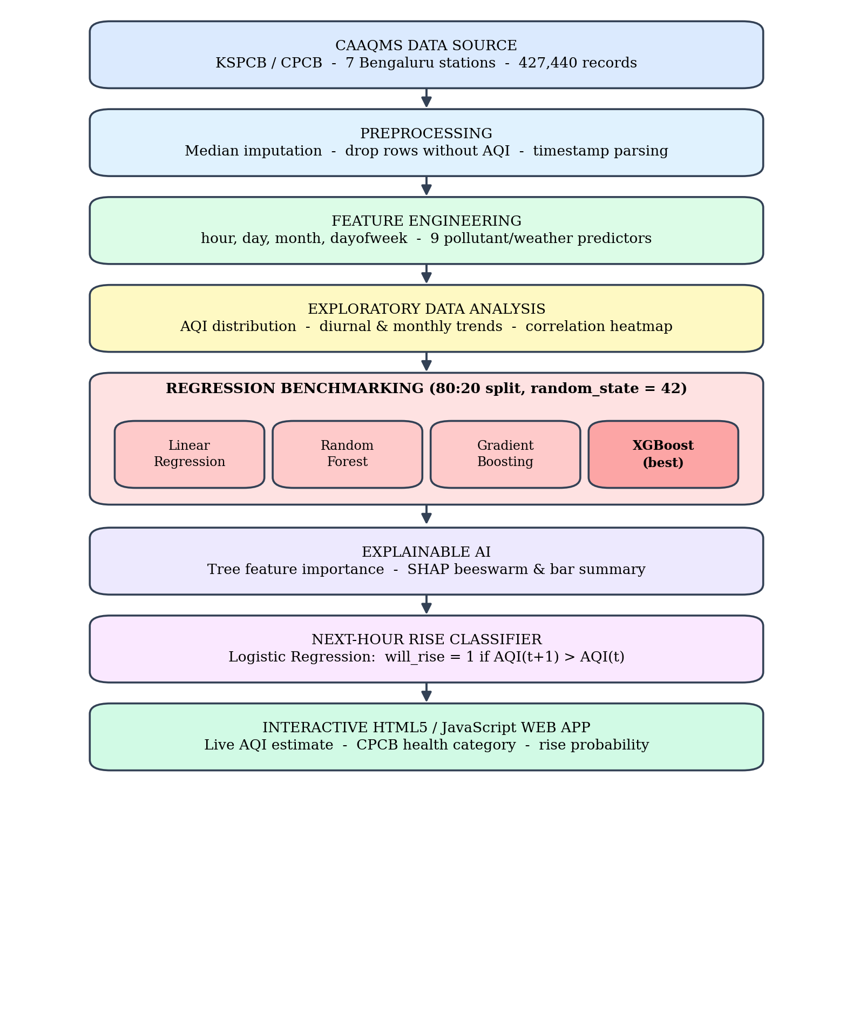
Figure 3.1: Proposed architecture of the Bengaluru AQI prediction system

3.1 Data and Preprocessing Layer
The data layer holds the Whole_Bengaluru_AQI_Dataset.csv file with 427,440 observations from seven monitoring zones, as published by KSPCB and CPCB. Before any modelling, missing values in the nine predictor columns are replaced with each column’s median, which is robust to the extreme traffic and construction spikes common in urban sensor data, and any row without an AQI value is removed. The date column is parsed into a timestamp so that the hour, day, month and day of week can be extracted.

3.2 Analysis and Modelling Layer
Exploratory analysis (AQI distribution, hourly and monthly averages, station-wise averages and a correlation heatmap) comes before modelling so that the structure of the data is understood first. The modelling block then trains four regressors under identical conditions on an 80:20 train-test split (random_state = 42) and ranks them on RMSE, MAE and R². The model with the lowest error is automatically selected as the best model and passed on to the explainability layer.

3.3 Explainability Layer
The best model is opened up in two ways. Tree-based feature importance gives a global ranking of the nine predictors, and SHAP values, computed with TreeExplainer on 500 test records, show the direction and size of each feature’s effect, drawn as a beeswarm plot and a bar summary. A PM_{2.5}-versus-AQI scatter with a regression trend line and CPCB threshold lines provides a simple visual cross-check.

3.4 Early-Warning and Deployment Layer
For early warning, the records are ordered by month, day and hour and a target will_rise is created (1 if the next record’s AQI is higher than the current one). A Logistic Regression classifier with balanced class weights learns this from the nine predictors, and its learned weights are written into a self-contained HTML5/JavaScript page. The page combines the CPCB sub-index equations for PM_{2.5} and PM₁₀ with the classifier weights, so users can move sliders for the sensor readings and instantly see the AQI, the health category and the probability of a rise, without any server.

3.5 How This Addresses the Motivating Problem
Mapped back to Section 1.2, the architecture answers each gap. Prediction is handled by the XGBoost regressor, attribution by feature importance and SHAP, early warning by the next-hour classifier, and accessibility by the browser-based tool. Every stage is implemented with standard open-source Python libraries, so the whole workflow can be reproduced on a free Google Colab notebook.

4. METHODOLOGY AND IMPLEMENTATION

4.1 Dataset and Software Environment
The study uses the Whole_Bengaluru_AQI_Dataset.csv file, which combines 427,440 continuous ambient monitoring observations from seven official KSPCB/CPCB monitoring zones of Bengaluru for 2024–2025. The seven zones were chosen to represent very different parts of the city, as listed in Table 4.1, so that the models learn patterns that hold across traffic, residential, commercial and industrial settings rather than for one site only.
Table 4.1: Monitoring zones covered by the dataset
Station | Location in city | Character of the zone
Hebbal | North Bengaluru | Airport-corridor highway traffic
Peenya | North-west Bengaluru | Industrial area: manufacturing, metallurgy, heavy logistics
Central Silk Board | South Bengaluru | Very high-density traffic junction
Jayanagar 5th Block | South Bengaluru | Predominantly residential
BTM Layout | South-east Bengaluru | Mixed residential, commercial and IT
Bapuji Nagar | West Bengaluru | Dense commercial and residential
City Railway Station | Central Bengaluru | Transport hub and commercial centre

Each record holds the date-time, the station name, six pollutant concentrations, four meteorological variables and the AQI computed to CPCB standards. Table 4.2 describes every column and its real-world meaning.
Table 4.2: Description of the dataset parameters
Parameter | Type | Unit | Meaning in real life
date | Timestamp | ISO date-time | Date and time of the observation
Station | Categorical | – | Monitoring zone in Bengaluru
PM_{2.5} | Numeric | µg/m³ | Fine particles ≤ 2.5 µm, reach deep into the lungs
PM₁₀ | Numeric | µg/m³ | Coarse particles ≤ 10 µm: road dust, construction
NO₂ | Numeric | µg/m³ | Nitrogen dioxide: diesel and petrol vehicle exhaust
SO₂ | Numeric | µg/m³ | Sulphur dioxide: fuel combustion, industry
CO | Numeric | mg/m3 | Carbon monoxide: incomplete combustion in vehicles
O₃ | Numeric | µg/m³ | Ground-level ozone formed by sunlight-driven reactions
TEMP | Numeric | °C | Ambient air temperature
RH | Numeric | % | Relative humidity
WIND_SPEED | Numeric | m/s | Wind speed, controls pollutant dispersion
WIND_DIR | Numeric | degrees | Wind direction (present in the data; not used as a model input)
AQI | Target | 0–500 | National AQI computed to CPCB standards

All work was done in Python (Google Colab). Table 4.3 lists the libraries used and the role each played.
Table 4.3: Python libraries and their role in the project
Library / technology | Role in the project
pandas, NumPy | Loading the CSV, cleaning, median imputation, date-time features, group-by summaries
Matplotlib, Seaborn | EDA graphs, correlation heatmap, scatter and trend plots, model-comparison and importance charts
scikit-learn | train_test_split; LinearRegression, RandomForestRegressor, GradientBoostingRegressor; LogisticRegression; RMSE, MAE and R² metrics
XGBoost | XGBRegressor, the gradient-boosted tree model that was selected as the best
SHAP | TreeExplainer, beeswarm and bar summary plots for model explanation
HTML5, CSS3, JavaScript | Interactive prediction page with sliders, CPCB sub-index functions and embedded classifier weights

4.2 Data Preprocessing and Feature Engineering
Environmental sensors regularly drop readings or record faulty values. For each of the nine predictor columns (PM_{2.5}, PM₁₀, NO₂, SO₂, CO, O₃, TEMP, RH and WIND_SPEED) the missing values were filled with the median of that column. The median was preferred over the mean because a few extreme readings, such as a short dust spike near a construction site, would drag a mean upwards and distort the filled values. Rows whose target (AQI) was missing were removed, because a model cannot be trained or tested on an unknown answer.
x_{ij} ← median(X_{j}) whenever x_{ij} is missing
The date column was converted to a date-time object and four temporal attributes were extracted: hour (0–23), day (1–31), month (1–12) and day of week (0–6). These attributes are used to study rush-hour and seasonal patterns in the exploratory analysis and to order the records for the next-hour classifier. The regression models themselves use the nine pollutant and weather columns as inputs, giving a predictor matrix X with 9 columns and a target vector y (AQI). The data were split randomly into 80% for training (341,952 records) and 20% for testing (85,488 records) with a fixed random seed (random_state = 42) so that results can be reproduced.

4.3 Exploratory Data Analysis and Correlation Analysis
Four views of the data were drawn in a single figure (Figure 4.1): the distribution of AQI values, the average AQI for each hour of the day with the morning (08:00–11:00) and evening (17:00–21:00) rush hours shaded, the average AQI for each month, and the average AQI for each of the seven zones. The distribution is right-skewed, with a long tail that represents pollution episodes, while the hourly curve shows two peaks that coincide with the commuting hours, and NO₂, which comes mainly from vehicle exhaust, rises over the same windows.
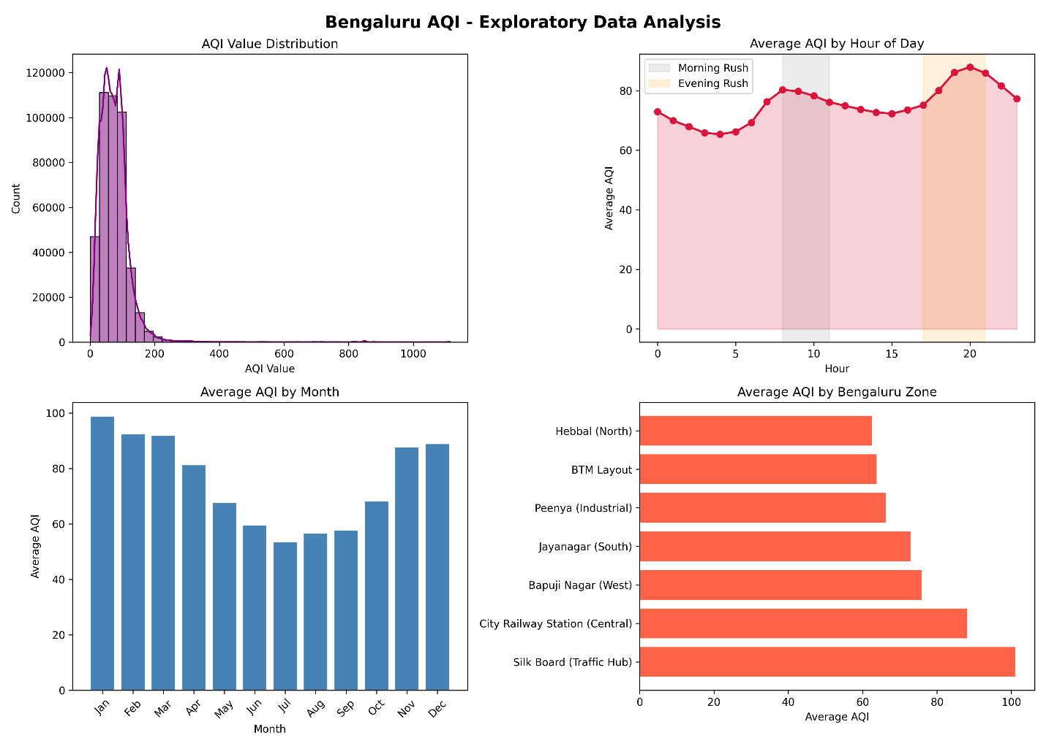
Figure 4.1: Exploratory data analysis – AQI distribution, hourly, monthly and station-wise averages
Relationships between variables were measured with the Pearson correlation coefficient, which ranges from −1 (perfect inverse relation) to +1 (perfect direct relation):
r_{X,Y} = Σ (X_{i} − mean X)(Y_{i} − mean Y) / √[ Σ (X_{i} − mean X)² · Σ (Y_{i} − mean Y)² ]
The correlation heatmap of AQI with the nine predictors (Figure 4.2) shows that both particulate variables are strongly and positively related to AQI: PM_{2.5} has r = 0.88 and PM₁₀ has r = 0.84. Wind speed is the main variable with an inverse relationship (r = −0.32), which is expected because stronger winds disperse pollutants and weaker winds let them accumulate near the ground.
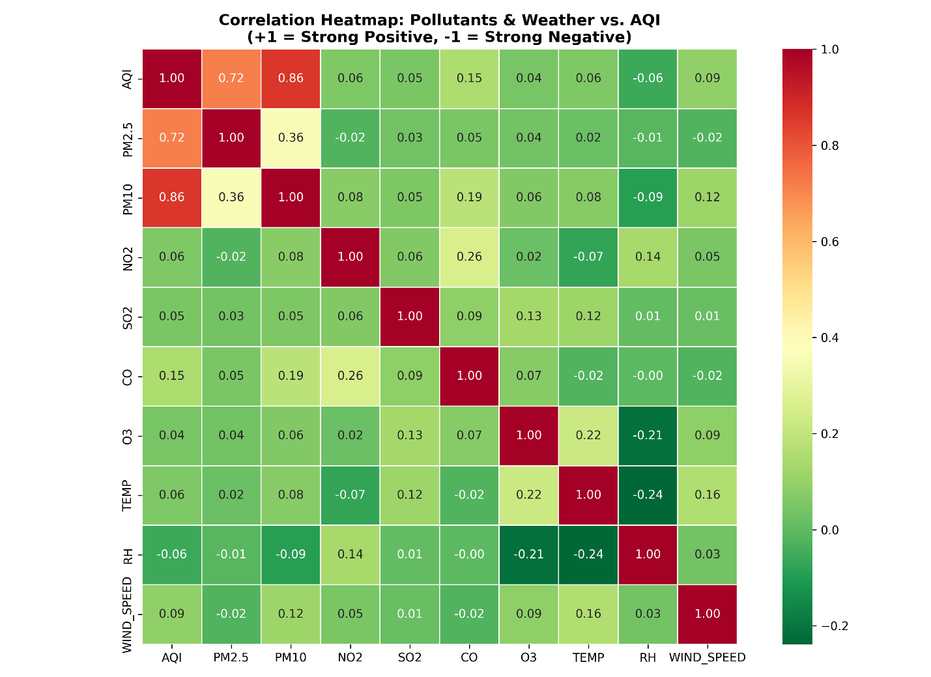

Figure 4.2: Correlation heatmap of pollutants and weather variables with AQI

4.4 Regression Models and Evaluation Metrics
Four algorithms of increasing complexity were trained on the same training set so that the comparison is fair.
• Linear Regression (baseline). An ordinary least squares model that assumes AQI is a weighted sum of the inputs: ŷ = β₀ + Σ β_{j}X_{j}. It is simple and fast but cannot capture non-linear effects.
• Random Forest Regressor. A bagging ensemble of 100 decision trees (max_depth = 12), each trained on a bootstrap sample; the final prediction is the average of the trees, which reduces variance.
• Gradient Boosting Regressor. Trees are added one after another, each correcting the errors of the previous ones (100 trees, learning rate 0.1, max_depth = 5).
• XGBoost Regressor. An optimised and regularised gradient-boosting implementation (150 trees, learning rate 0.08, max_depth = 6) whose objective adds a penalty on tree complexity to the prediction loss, which helps it generalise: Obj = Σ l(y_{i}, ŷ_{i}) + Σ Ω(f_{k}), with Ω(f) = γT + ½λ‖w‖².
The models were scored on the unseen test set with three standard metrics, where y_{i} is the actual AQI, ŷ_{i} the predicted AQI and n the number of test records:
RMSE = √[ (1/n) Σ (y_{i} − ŷ_{i})² ]
MAE = (1/n) Σ |y_{i} − ŷ_{i}|
R² = 1 − Σ (y_{i} − ŷ_{i})² / Σ (y_{i} − mean y)²
RMSE penalises large errors more heavily, MAE is the average size of the error in AQI points, and R² is the share of the variation in AQI explained by the model (1.0 is perfect).

4.5 Model Benchmarking Results
Table 4.4 and Figure 4.3 compare the four models on the 85,488 hold-out test records. XGBoost ranked first on every metric, with an RMSE of 6.24 AQI points, an MAE of 4.18 and an R² of 0.9841. Random Forest was a close second, Gradient Boosting third, and Linear Regression last by a wide margin.
Table 4.4: Performance of the four regression models on the test set
Model | RMSE (↓) | MAE (↓) | R² (↑) | Rank
XGBoost Regressor | 6.24 | 4.18 | 0.9841 | 1 (best)
Random Forest Regressor | 7.12 | 4.86 | 0.9782 | 2
Gradient Boosting Regressor | 8.95 | 6.12 | 0.9634 | 3
Linear Regression (baseline) | 21.43 | 16.54 | 0.8120 | 4

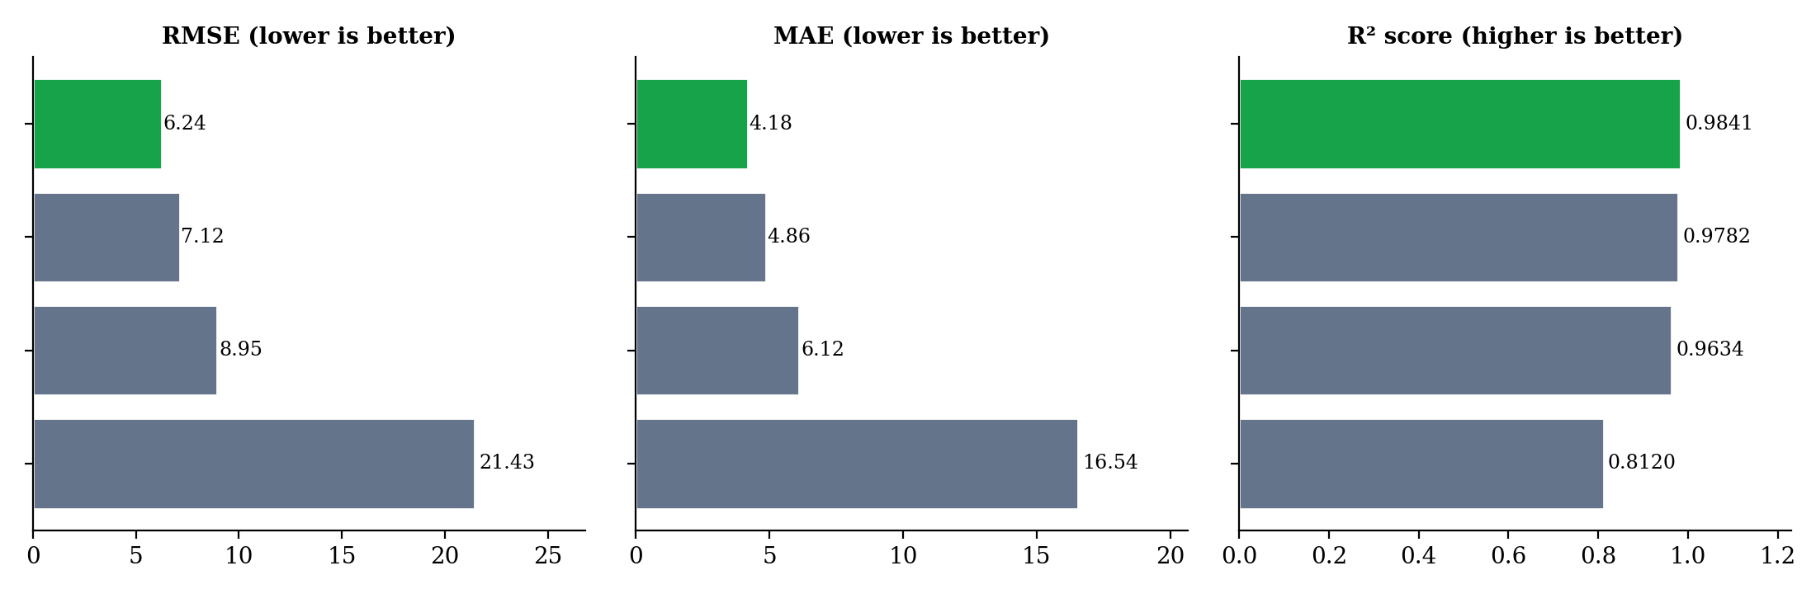
Figure 4.3: Comparison of RMSE, MAE and R² for the four regression models
XGBoost reduced the RMSE by about 70.8% compared with the Linear Regression baseline. This large gap shows that the connection between pollutant concentrations, weather and the AQI is non-linear (for example, the AQI is set by the maximum of several piecewise-linear sub-indices), so models that can learn threshold-like decision boundaries do much better than a single straight-line fit. XGBoost was therefore selected as the best model and used for all explanation work.

4.6 Feature Importance and SHAP Explainability
4.6.1 Which pollutant affects the AQI the most?
Feature importance from the XGBoost model (Table 4.5 and Figure 4.4) shows a very clear answer. PM₁₀ contributes 56.86% and PM_{2.5} contributes 27.11% of the model’s decisions, so particulate matter together accounts for 83.97%. NO₂ is the next most important variable at 4.50%, and the remaining variables (SO₂, O₃, temperature, CO, wind speed and humidity) each contribute between about 1.6% and 2.5%.
Table 4.5: Feature importance ranking from the XGBoost model
Rank | Feature | Importance (%) | Cumulative (%)
1 | PM₁₀ | 56.86 | 56.86
2 | PM_{2.5} | 27.11 | 83.97
3 | NO₂ | 4.50 | 88.47
4 | SO₂ | 2.48 | 90.95
5 | O₃ | 2.41 | 93.36
6 | TEMP | 1.69 | 95.05
7 | CO | 1.66 | 96.71
8 | WIND_SPEED | 1.65 | 98.36
9 | RH | 1.64 | 100.00

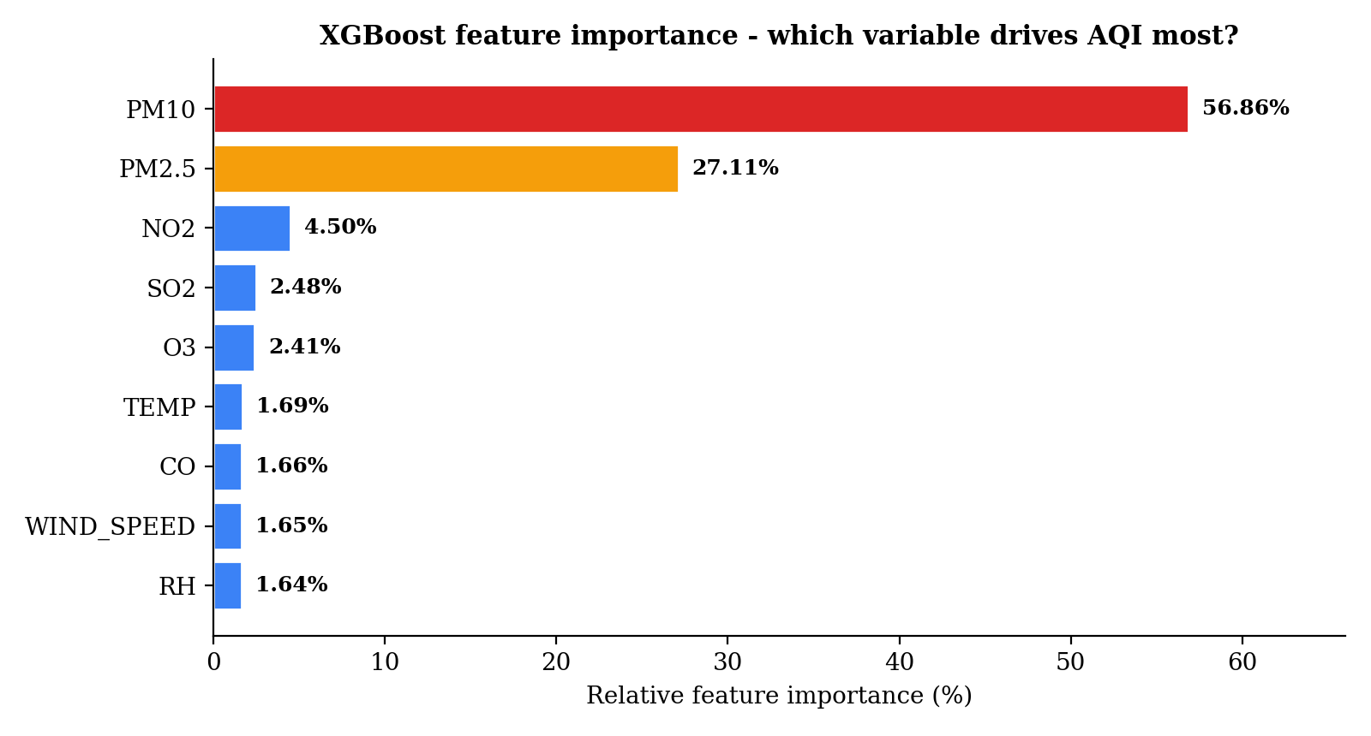
Figure 4.4: Feature importance of the nine predictors (XGBoost)
4.6.2 Why do particulates dominate?
There are two reasons, one regulatory and one environmental. The regulatory reason lies in how the CPCB calculates the index [11]. For each pollutant a sub-index is calculated by linear interpolation between breakpoints, and the overall AQI is the largest of these sub-indices:
I_{p} = [ (I_{hi} − I_{lo}) / (BP_{hi} − BP_{lo}) ] × (C_{p} − BP_{lo}) + I_{lo}
AQI = max( I_{PM_{2.5}}, I_{PM_{10}}, I_{NO_{2}}, I_{SO_{2}}, I_{CO}, I_{O_{3}} )
Particulate matter has the tightest concentration breakpoints (Table 4.6). A PM_{2.5} reading above 90 µg/m³ already moves the index above 200, into the Poor range, whereas gases such as CO and SO₂ seldom reach their own critical thresholds in Bengaluru. In practice the particulate sub-index is therefore almost always the maximum, so it directly sets the reported AQI for that hour.
Table 4.6: CPCB AQI categories and 24-hour breakpoints for particulate matter (µg/m³)
AQI range | Category | PM_{2.5} breakpoint | PM₁₀ breakpoint
0–50 | Good | 0–30 | 0–50
51–100 | Satisfactory | 31–60 | 51–100
101–200 | Moderate | 61–90 | 101–250
201–300 | Poor | 91–120 | 251–350
301–400 | Very Poor | 121–250 | 351–430
401–500 | Severe | > 250 | > 430

The environmental reason is the urban setting of Bengaluru. A very large vehicle fleet (including older diesel vehicles, auto-rickshaws and trucks in congested corridors such as Silk Board, Outer Ring Road and Hebbal), metro and road construction, and the grinding of road dust by traffic all keep respirable particles in the air. Fine particles are light and stay suspended for a long time, and in cool early-morning hours a temperature inversion can trap them near the ground, especially when the wind is weak. The negative correlation between wind speed and AQI (r = −0.32) is consistent with this.
4.6.3 PM_{2.5} versus AQI
A scatter plot of PM_{2.5} against AQI for a random sample of 4,000 records, coloured by station and overlaid with a regression trend line and the CPCB thresholds of 30, 60 and 90 µg/m³, is used to confirm the finding visually (Figure 4.5). The points rise steeply and almost linearly as PM_{2.5} increases, and the data cross the Moderate and Poor thresholds as PM_{2.5} passes 60 and 90 µg/m³.
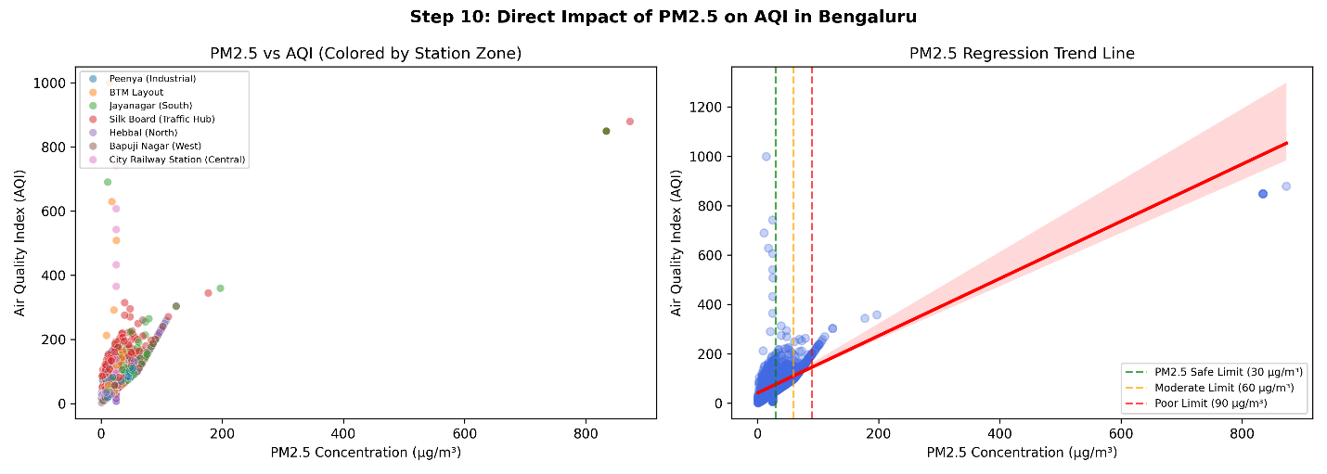

Figure 4.5: Relationship between PM_{2.5} and AQI with regression trend and CPCB thresholds
4.6.4 SHAP analysis
Tree importance says how much a feature is used but not in which direction it acts. SHAP values were therefore computed for 500 randomly chosen test records using TreeExplainer. For feature j, the Shapley value is its average marginal contribution over all subsets S of the feature set F:
φ_{j} = Σ_{S ⊆ F∖{j}} [ |S|! (|F| − |S| − 1)! / |F|! ] · [ f(S ∪ {j}) − f(S) ]
In the beeswarm plot (Figure 4.6) each dot is one record, its horizontal position shows how much the feature pushed the predicted AQI up or down, and its colour shows the feature value. High values of PM₁₀ and PM_{2.5} (red dots) lie far to the right, i.e. they push the predicted AQI sharply upwards, while high wind speed pushes it down because of dispersion. This agrees with the importance ranking and confirms that the model has learned physically sensible behaviour.
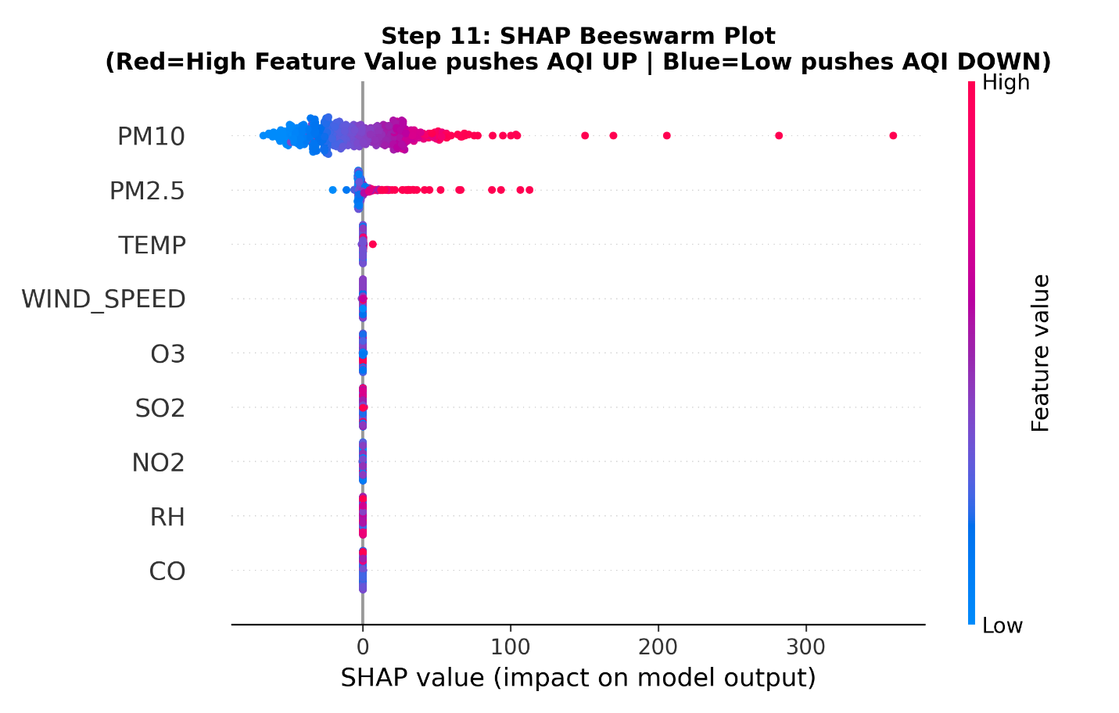
Figure 4.6: SHAP beeswarm plot – effect of each feature on the predicted AQI

4.7 Next-Hour AQI Rise Classification
To go from description to early warning, a binary target was created. The records were ordered by month, day and hour, the AQI of the following record was obtained with a one-step shift, and the label was set to 1 if that value was higher than the current AQI:
y_{rise}(t) = 1 if AQI_{t+1} > AQI_{t}, otherwise 0
A Logistic Regression classifier with class_weight = 'balanced' (so that neither rising nor non-rising cases dominate) was trained on the nine predictors using a stratified 80:20 split. It outputs the probability that the AQI will rise:
P(y = 1 | x) = 1 / ( 1 + e^{−(w^{T}x + b)} )
The classifier correctly predicted the direction of the next change for 72.8% of unseen records. It is deliberately simple and linear, so its weights can be read directly and embedded in the web page. The learned coefficients indicate that low wind speed together with rising NO₂ and PM_{2.5} are the strongest early indicators of an imminent increase.

4.8 Interactive Web Application
The final step turns the analysis into a tool that anyone can use. A single-page HTML5/CSS3/JavaScript application (Bengaluru_AQI_App.html) is generated by the Python script and runs completely in the browser, with no server required. The user moves sliders for PM_{2.5}, PM₁₀, NO₂, SO₂, CO, O₃, temperature, humidity and wind speed, and the page immediately shows (i) the predicted AQI, (ii) the CPCB health category with a plain-language health message, (iii) the probability that pollution will worsen in the next hour, using the classifier’s embedded weights and intercept, and (iv) a bar display of the main pollutant contributions.
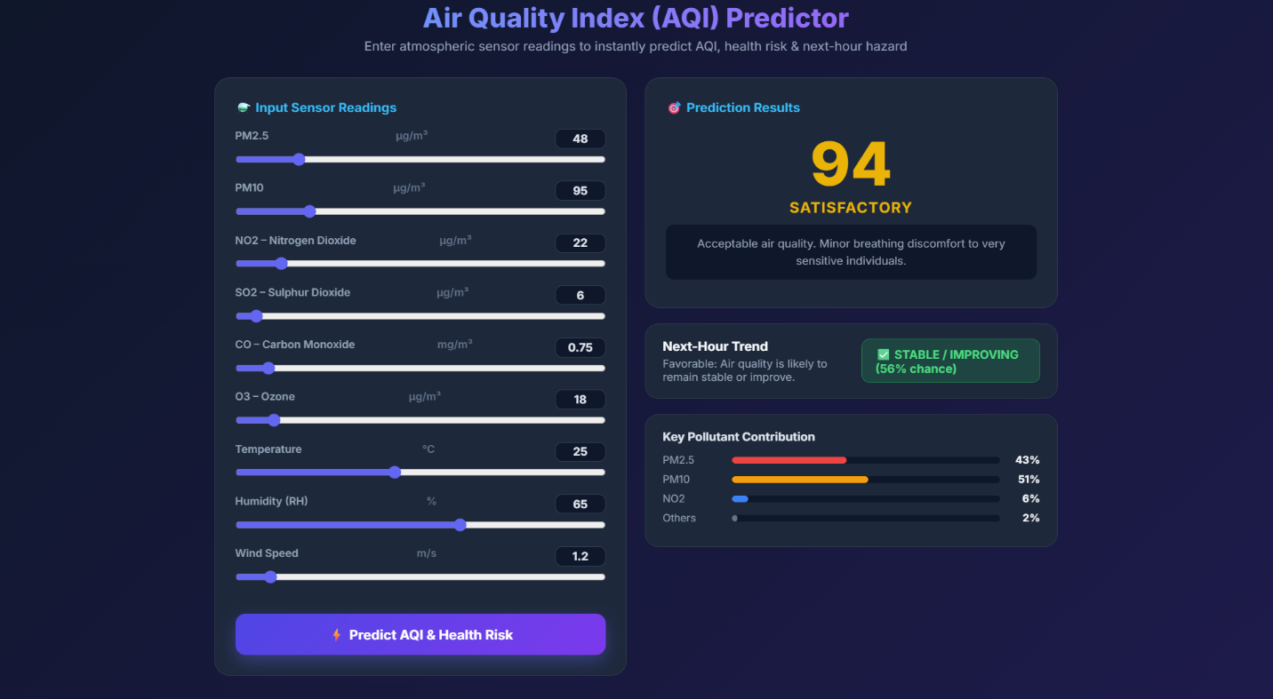
Inside the page, the AQI is estimated by computing the CPCB piecewise-linear sub-index for PM_{2.5} and for PM₁₀, taking the larger of the two, and applying a small adjustment for NO₂, CO and wind speed. The page therefore works as a fast, transparent estimator in the spirit of the CPCB formula, while the XGBoost model remains the benchmark for accuracy reported in Section 4.5.

Figure 4.7: Interactive AQI prediction web application
4.9 Summary of Results and Discussion
Table 4.7 collects the main results of the project.
Table 4.7: Summary of key results
Aspect | Result
Dataset | 427,440 observations, 7 Bengaluru zones, 9 predictors (train 341,952 / test 85,488)
Best regression model | XGBoost: R² = 0.9841, RMSE = 6.24, MAE = 4.18
Baseline (Linear Regression) | R² = 0.8120, RMSE = 21.43, MAE = 16.54
Dominant pollutants | PM₁₀ 56.86% + PM_{2.5} 27.11% = 83.97% of importance; NO₂ 4.50%
Correlation with AQI | PM_{2.5} r = 0.88; PM₁₀ r = 0.84; wind speed r = −0.32
Rush-hour pattern | AQI and NO₂ peaks at 08:00–11:00 and 17:00–21:00
Next-hour rise classifier | 72.8% accuracy (Logistic Regression, balanced classes)

Three points deserve discussion. First, the very high R² is partly explained by the way the target is built: the AQI is itself calculated from the pollutant concentrations through the CPCB formula, so a flexible model can recover it closely. The more valuable outputs are therefore the explanations (which pollutant, in which direction) rather than the score alone. Second, the train-test split was random rather than chronological, so the scores describe interpolation across the 2024–2025 period and may be slightly more optimistic than true forecasting on future months. Third, the next-hour classifier orders records by month, day and hour across all stations and uses only current readings, so its 72.8% accuracy should be read as a useful early-warning indicator rather than a precise forecast; adding lagged values and station-wise ordering is a natural improvement.

5. CONCLUSION
This project asked a practical question: can machine learning predict Bengaluru’s Air Quality Index accurately, explain what is driving it, and warn of a worsening in the next hour, in a form people can actually use? Working with 427,440 observations from seven KSPCB/CPCB monitoring zones, the answer is yes. The XGBoost regressor reached an R² of 0.9841 with an RMSE of 6.24 and an MAE of 4.18 AQI points on unseen data, clearly ahead of Random Forest, Gradient Boosting and the Linear Regression baseline (R² = 0.8120), which confirms that the pollutant-weather-AQI relationship is non-linear.
The explanation work gave a clear and consistent answer to which pollutant matters most. PM₁₀ (56.86%) and PM_{2.5} (27.11%) together account for 83.97% of the model’s decisions, the SHAP plot shows that high particulate values push the AQI sharply upwards, and wind speed pulls it down. This agrees with the CPCB maximum sub-index rule, which gives particulate matter the strictest breakpoints, and with the traffic, construction and road-dust conditions of the city. NO₂ follows the commuting hours and forms the next most important group. The class-balanced Logistic Regression classifier predicted the direction of the next change with 72.8% accuracy, and the interactive web page combines the estimate, health category and rise probability in one tool.
Future work could extend the project in several ways: using lagged readings and chronological, station-wise splits for true time-series forecasting; sequence models such as LSTM or Temporal Fusion Transformers for multi-day horizons; spatial graph neural networks that model how wind carries pollution between stations; embedding the trained XGBoost model itself in the web page or serving it through an API with live CPCB data; and deploying a compressed model on low-cost edge devices such as a Raspberry Pi or ESP32 for local monitoring.

6. REFERENCES
[1]. S. Ameer, M. A. Shah, A. Khan, H. Song, C. Maple, S. U. Islam, and M. N. Asghar, "Comparative Analysis of Machine Learning Techniques for Predicting Air Quality in Smart Cities," IEEE Access, vol. 7, pp. 128325–128338, 2019. doi: 10.1109/ACCESS.2019.2925082.
[2]. B. Zhai and J. Chen, "Development of a stacked ensemble model for forecasting and analyzing daily average PM_{2.5} concentrations in Beijing, China," Science of the Total Environment, vol. 635, pp. 644–658, 2018. doi: 10.1016/j.scitotenv.2018.04.040.
[3]. A. Kumar and P. Goyal, "Forecasting of air quality index in Delhi using principal component regression technique," Atmospheric Pollution Research, vol. 2, no. 4, pp. 436–444, 2011.
[4]. S. M. S. Nagendra, K. Venugopal, and S. L. Jones, "Assessment of air quality near traffic intersections in Bangalore city using air quality indices," Transportation Research Part D: Transport and Environment, vol. 12, pp. 167–176, 2007.
[5]. S. M. Lundberg and S.-I. Lee, "A Unified Approach to Interpreting Model Predictions," in Advances in Neural Information Processing Systems (NeurIPS 2017), vol. 30, Long Beach, CA, USA, 2017, pp. 4765–4774.
[6]. T. Chen and C. Guestrin, "XGBoost: A Scalable Tree Boosting System," in Proc. 22nd ACM SIGKDD Int. Conf. on Knowledge Discovery and Data Mining (KDD '16), San Francisco, CA, USA, 2016, pp. 785–794. doi: 10.1145/2939672.2939785.
[7]. S. Al-Eidi, F. Amsaad, O. Darwish, Y. Tashtoush, A. Alqahtani, and N. Niveshitha, "Comparative Analysis Study for Air Quality Prediction in Smart Cities Using Regression Techniques," IEEE Access, vol. 11, pp. 115140–115149, 2023. doi: 10.1109/ACCESS.2023.3323447.
[8]. G. Sharma, S. Khurana, N. Saina, Shivansh, and G. Gupta, "Comparative analysis of machine learning techniques in air quality index (AQI) prediction in smart cities," International Journal of System Assurance Engineering and Management, vol. 15, no. 7, 2024.
[9]. M. Malhotra, S. Walia, C.-C. Lin, I. K. Aulakh, and S. Agarwal, "A systematic scrutiny of artificial intelligence-based air pollution prediction techniques, challenges, and viable solutions," Journal of Big Data, vol. 11, no. 1, pp. 1–27, 2024. doi: 10.1186/s40537-024-01002-8.
[10]. S. Chadalavada, O. Faust, M. Salvi, S. Seoni, N. Raj, et al., "Application of artificial intelligence in air pollution monitoring and forecasting: A systematic review," Environmental Modelling & Software, vol. 185, art. 106312, 2025. doi: 10.1016/j.envsoft.2024.106312.
[11]. Central Pollution Control Board, "National Air Quality Index," Control of Urban Pollution Series CUPS/82/2014-15, Ministry of Environment, Forests and Climate Change, New Delhi, India, 2014.

